APPLICATION OF DOROTHEA OREM'S SELF-CARE DEFICIT THEORY IN MANAGING PATIENT'S USING INSULIN INJECTION.

Orem’s Theory.
Dorothy Orem defines self-care as actions that people can launch willingly to make sure that the quality of life is advanced by ensuring effective psychological, mental, physical, and social health
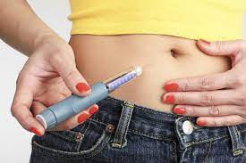
Importance of Orem’s theory.
it helps patients learn that they can recover faster and efficiently if they take control of their health.

Importance of insulin self care
- Avoids frequent visits to the ER.
- To learn effective way of insulin administration
- To improve quality of life.
Dependent care.
For patients that are dependent on other people to take care of them, the care takers will undergo the lessons on how to administer the insulin injections.
Nursing research.
Research by (Poudel et al, 2018) argues that Proper insulin injection practice is essential for better diabetic control

QSEN Competencies.
- Patient-centered care.
The program will provide compassionate and coordinated care based on respect for the patient’s preferences, values, and needs.
- Teamwork.
The program will foster open communication, mutual respect, and share decision making to achieve quality patient care.
- Evidence based programs.
The program will consider the preferences of the patient by looking at evidence of previous care.
- Quality management.
The program will ensure that patients are their caretakers are familiar with strategies of administering quality injections.
- Safety
The program will keep the patient and staff free from harm and minimize errors in care,
- Informatics
The use of HER will ensure access and use of information and electronic tech to communicate, manage knowledge, prevent error and support decision making
Conclusion.
This self-care education will not only help the patients facing diabetes but also those living with them.
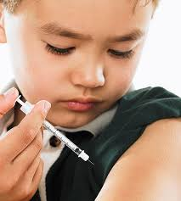
Reference.
Poudel, R. S., Shrestha, S., Piryani, R. M., Basyal, B., Kaucha, K., & Adhikari, S. (2017). Assessment of insulin injection practice among diabetes patients in a tertiary healthcare centre in Nepal: a preliminary study. Journal of diabetes research, 2017.

Fighting diabetes can save lives.
THANK YOU

